Rhombicosidodecahedron

Definition
# Source: AI Source: Provided by: [Data Path: Persons Table -> ID Column: 1, Name_En Column: Motasem Essam] -> From: [ChatGPT] on [7/25/2026]
A Rhombicosidodecahedron is a convex Archimedean solid composed of 62 regular polygonal faces: 20 equilateral triangles, 30 squares, and 12 regular pentagons.
It has 60 vertices and 120 edges. Every vertex has the same arrangement of faces: one triangle, two squares, and one pentagon.

Geometric Structure
# Source: AI Source: Provided by: [Data Path: Persons Table -> ID Column: 1, Name_En Column: Motasem Essam] -> From: [ChatGPT] on [7/25/2026]
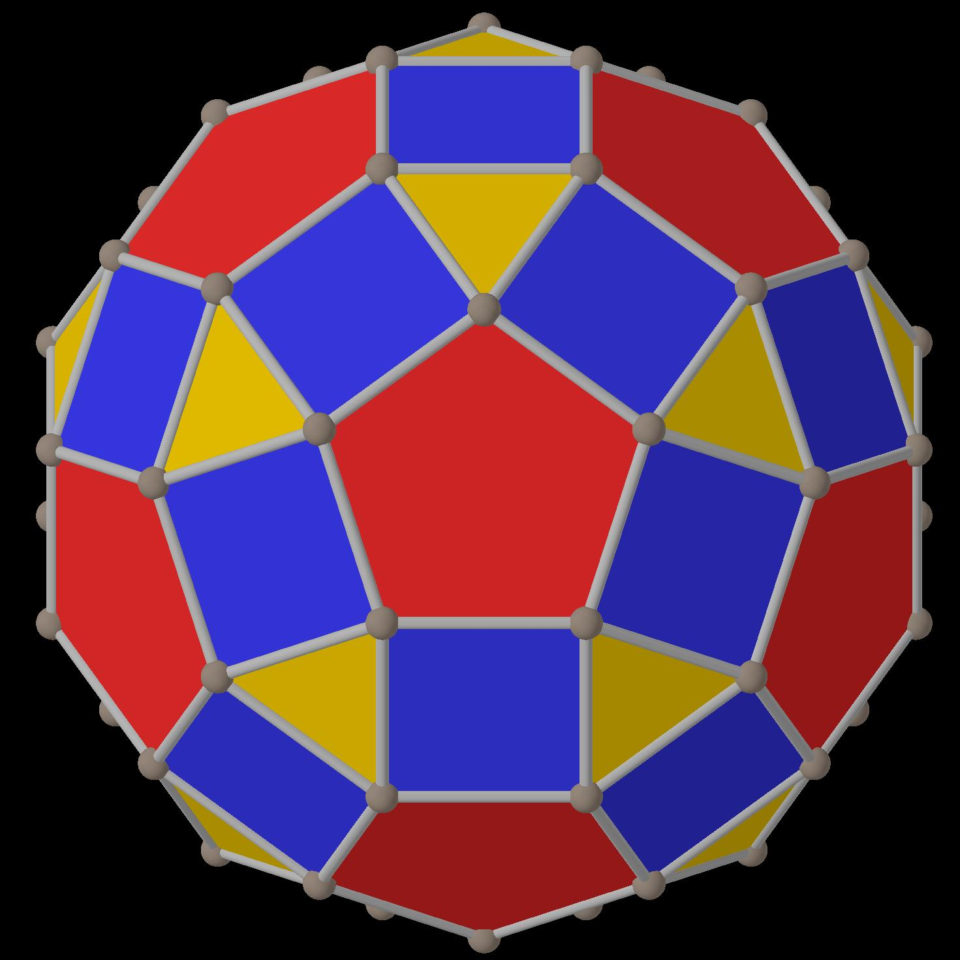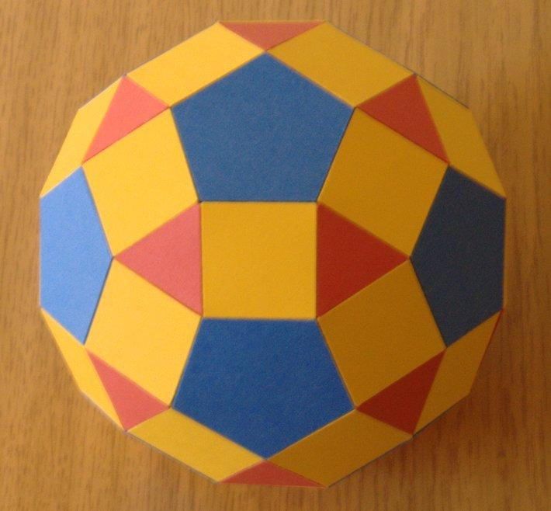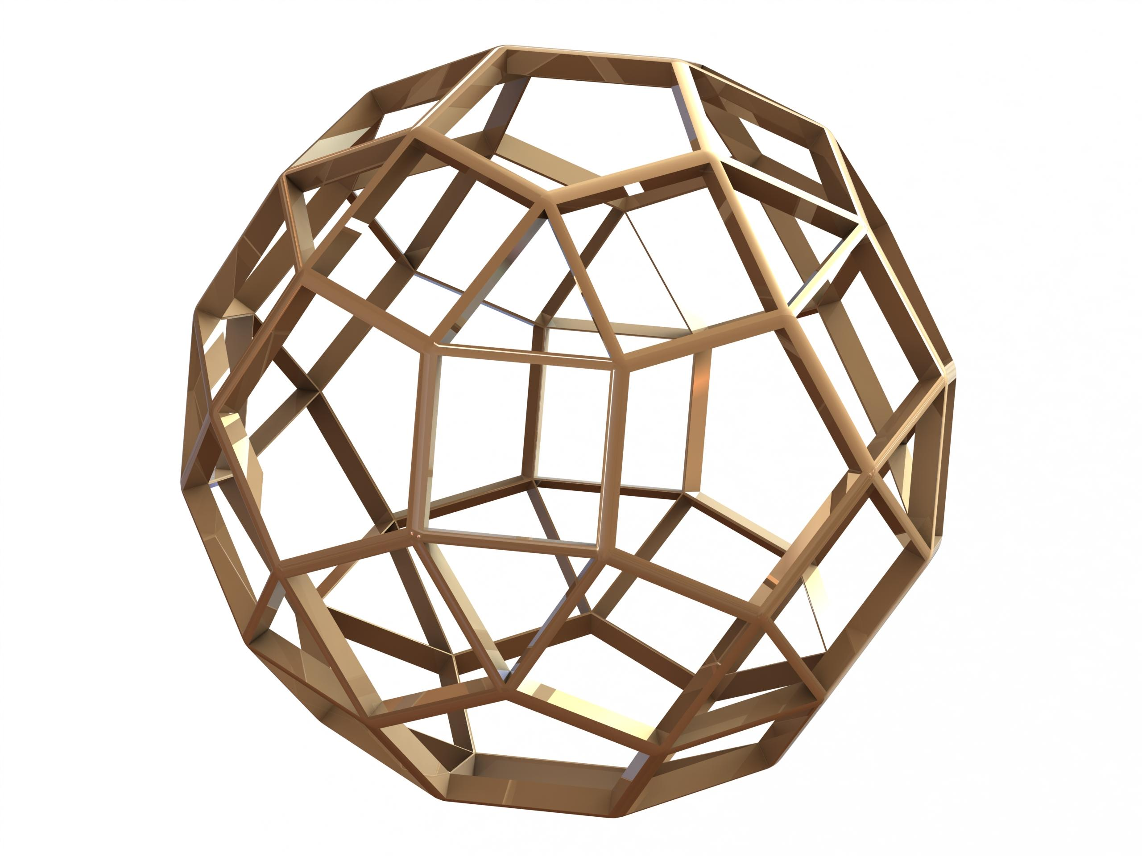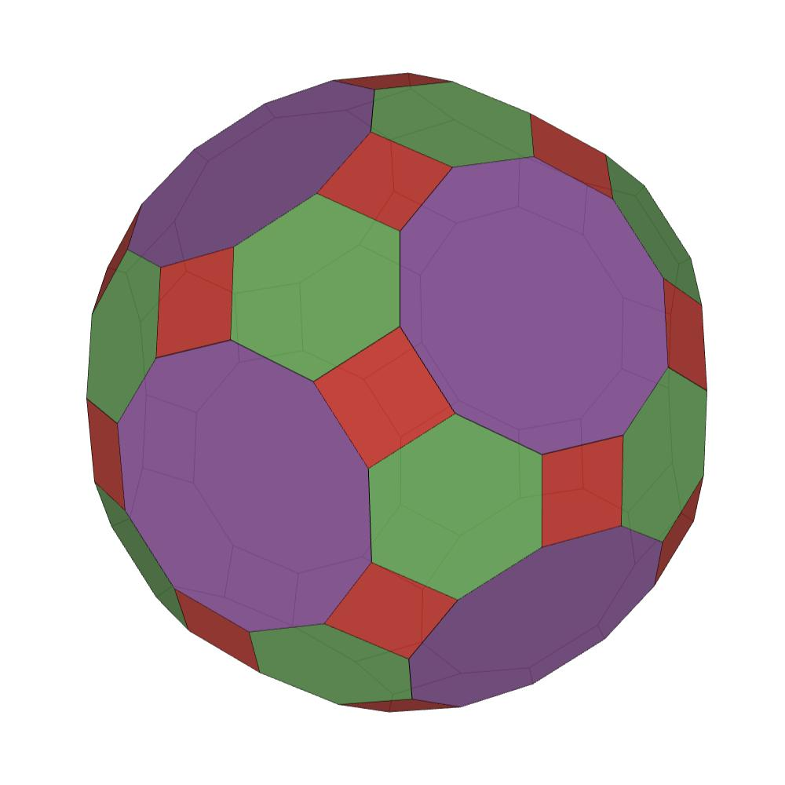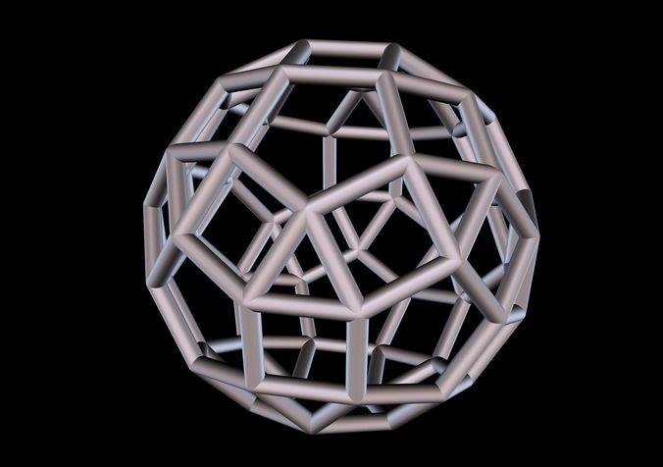
The solid consists of three types of regular polygonal faces:
- 20 Triangular Faces: Equilateral triangles.
- 30 Square Faces: Regular squares.
- 12 Pentagonal Faces: Regular pentagons.
Its faces are arranged uniformly around every vertex.

Face Composition
# Source: AI Source: Provided by: [Data Path: Persons Table -> ID Column: 1, Name_En Column: Motasem Essam] -> From: [ChatGPT] on [7/25/2026]
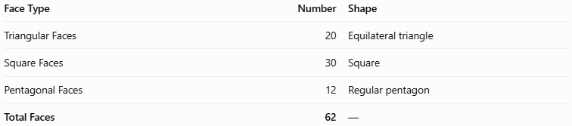
Face Type | Number | Shape
Triangular Faces | 20 | Equilateral triangle
Square Faces | 30 | Square
Pentagonal Faces | 12 | Regular pentagon
Total Faces | 62 | —

Mathematical Properties
# Source: AI Source: Provided by: [Data Path: Persons Table -> ID Column: 1, Name_En Column: Motasem Essam] -> From: [ChatGPT] on [7/25/2026]
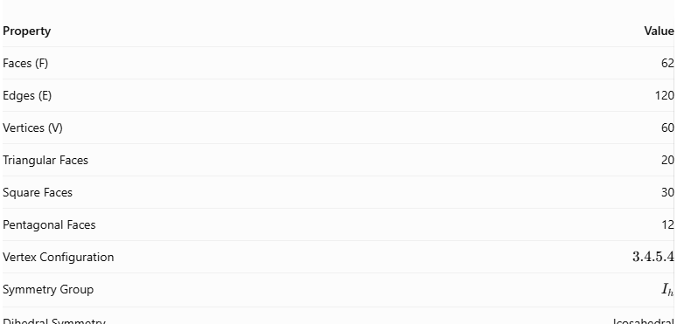
Property | Value
Faces (F) | 62
Edges (E) | 120
Vertices (V) | 60
Triangular Faces | 20
Square Faces | 30
Pentagonal Faces | 12
Vertex Configuration | $$3.4.5.4$$
Symmetry Group | $$I_{h}$$
Dihedral Symmetry | Icosahedral
Euler's Formula:
$$V-E+F=2$$
$$60-120+62=2$$
Surface Area:
For edge length $a$:
$$A=(30+5\sqrt{3}+3\sqrt{25+10\sqrt{5}})a^{2}$$
Volume:
$$V=\frac{1}{3}(60+29\sqrt{5}+12\sqrt{15+6\sqrt{5}})a^{3}$$
Correction to the volume formula: The correct formula is:
$$V=\frac{60+29\sqrt{5}}{3}a^{3}$$
The surface-area formula is:
$$A=(30+5\sqrt{3}+3\sqrt{25+10\sqrt{5}})a^{2}$$
These formulas apply when all edges have length $a$.

Geometric Characteristics
# Source: AI Source: Provided by: [Data Path: Persons Table -> ID Column: 1, Name_En Column: Motasem Essam] -> From: [ChatGPT] on [7/25/2026]
- It is a convex Archimedean solid.
- It is also called the Small Rhombicosidodecahedron.
- All faces are regular polygons.
- All edges have equal length.
- All vertices have identical arrangements of faces.
- It has full icosahedral symmetry, represented by $I_{h}$.
- Its vertex configuration is $3.4.5.4$, meaning that a triangle, square, pentagon, and square meet at each vertex.
- Its dual is the Deltoidal Hexecontahedron (also called the Deltoidal Icositetrahedron? No—the correct name here is Deltoidal Hexecontahedron).

Geometric Construction
# Source: AI Source: Provided by: [Data Path: Persons Table -> ID Column: 1, Name_En Column: Motasem Essam] -> From: [ChatGPT] on [7/25/2026]
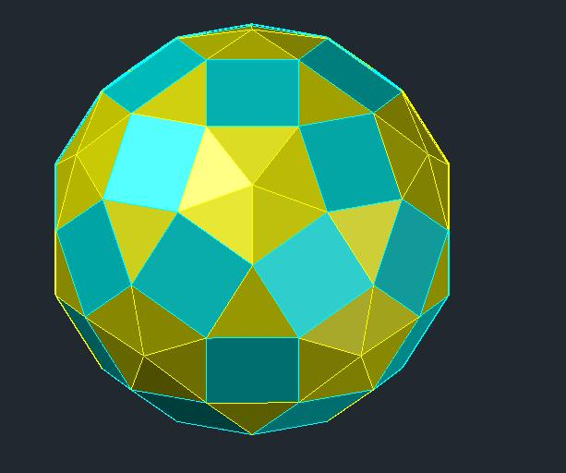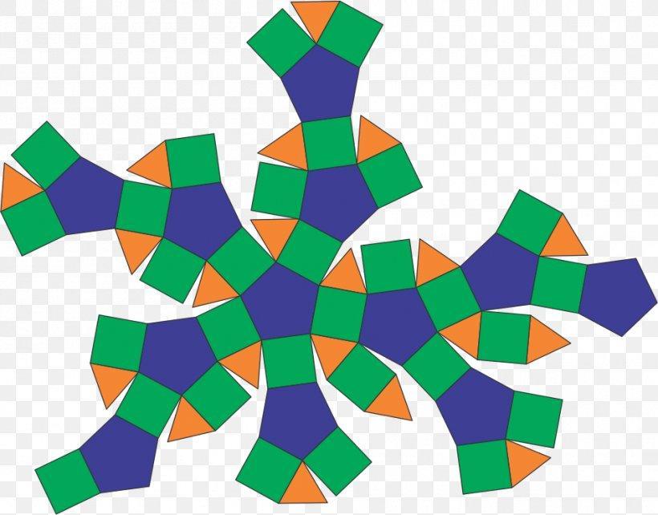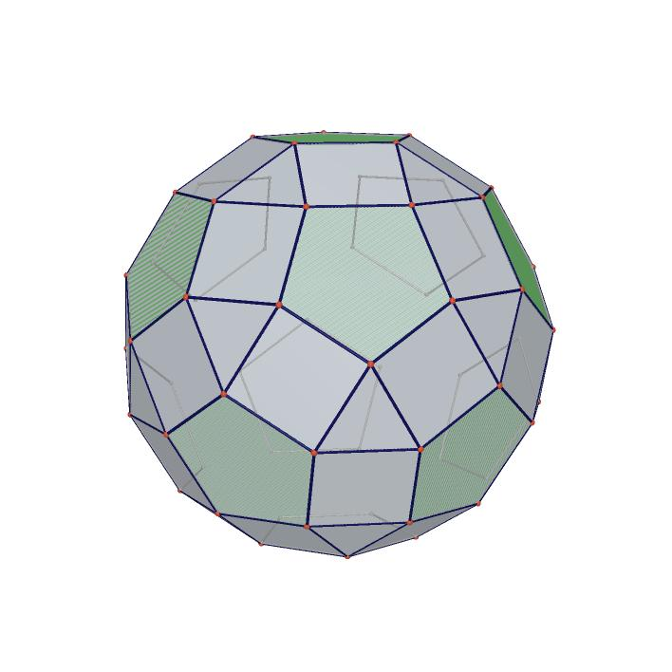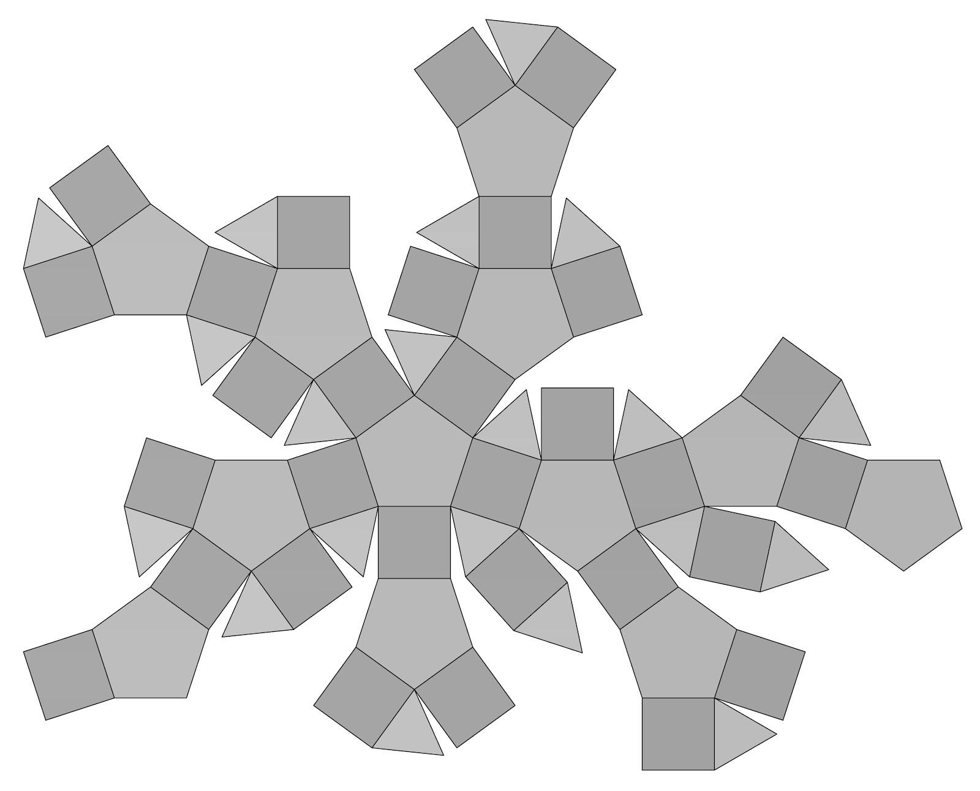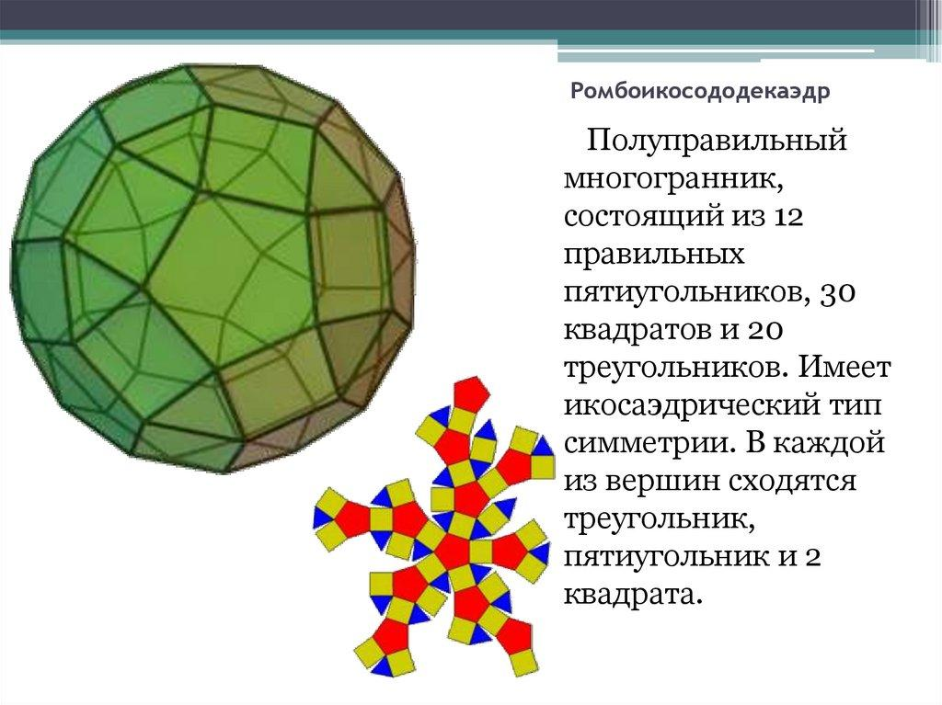
The Rhombicosidodecahedron can be obtained by expanding an icosidodecahedron:
- Separate its original faces by moving them outward while preserving their orientations.
- Create square regions between the separated faces.
- Fill the remaining gaps with equilateral triangles.
- Arrange the resulting faces so that the complete solid has identical vertex configurations.
The resulting solid contains 20 triangles, 30 squares, and 12 pentagons.

Related Geometric Solids
# Source: AI Source: Provided by: [Data Path: Persons Table -> ID Column: 1, Name_En Column: Motasem Essam] -> From: [ChatGPT] on [7/25/2026]
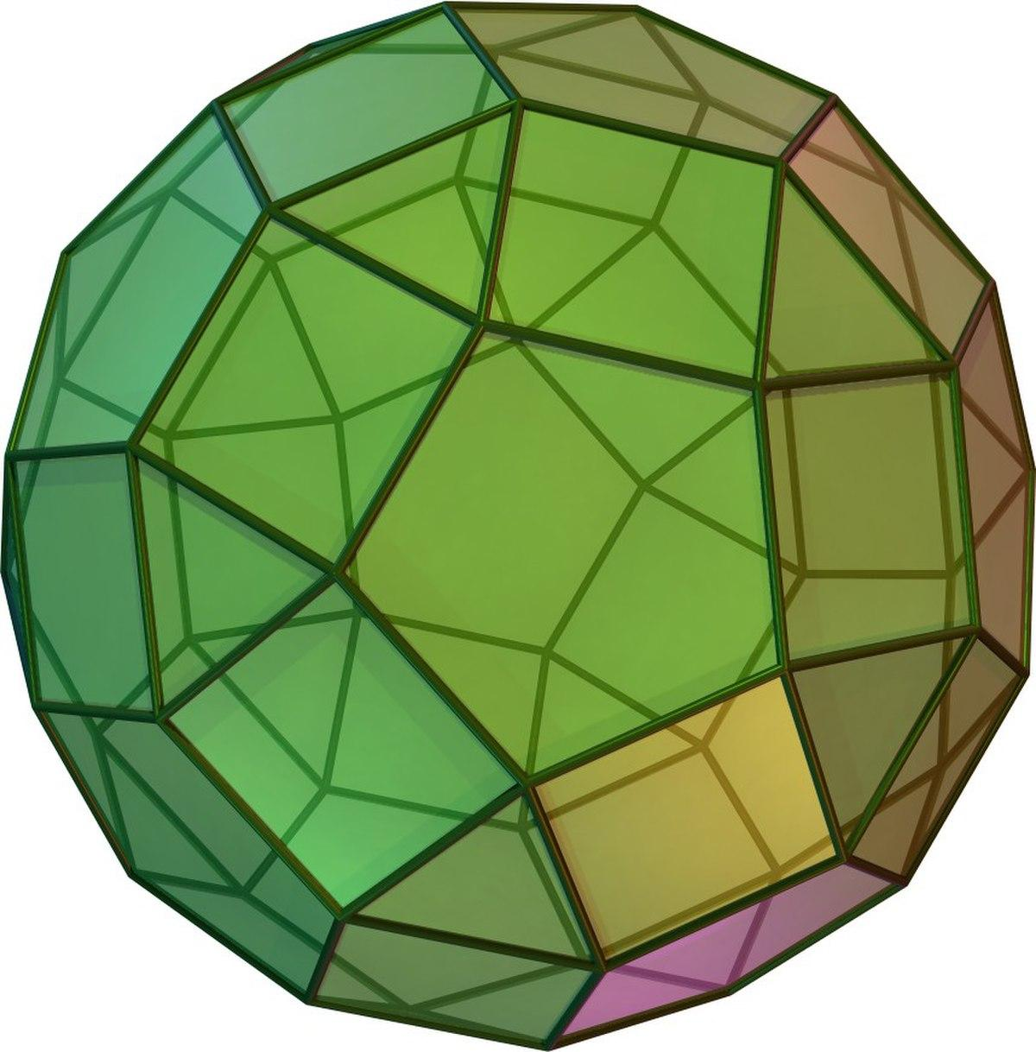
Icosidodecahedron
A related Archimedean solid containing 20 triangles and 12 pentagons.
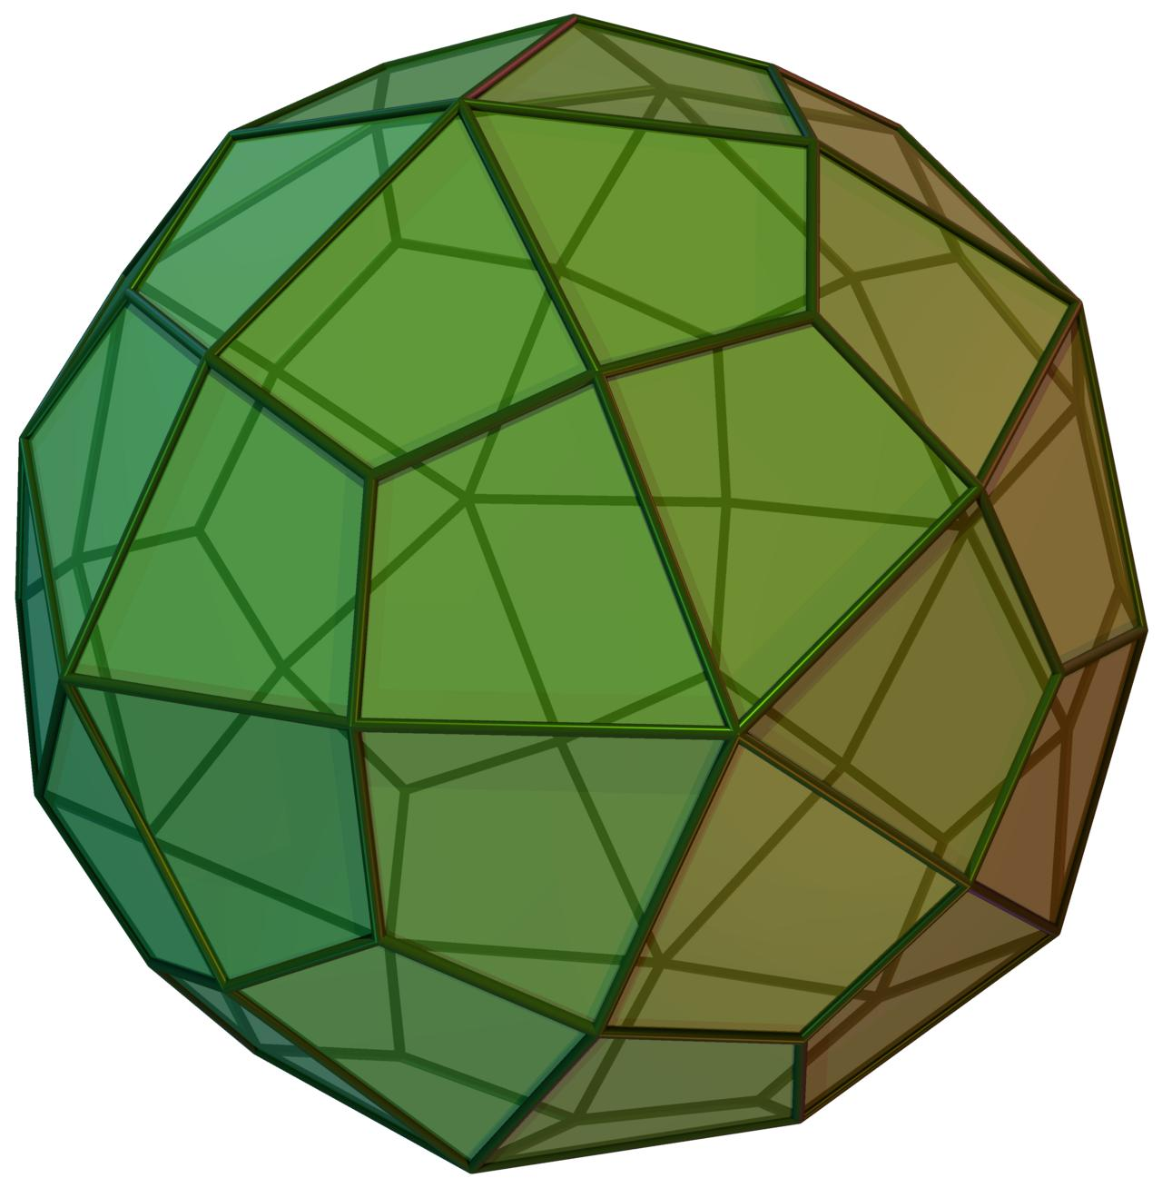
Deltoidal Hexecontahedron
The dual polyhedron of the Rhombicosidodecahedron.
Great Rhombicosidodecahedron
A different Archimedean solid, composed of 30 squares, 20 hexagons, and 12 decagons.

Key Points
# Source: AI Source: Provided by: [Data Path: Persons Table -> ID Column: 1, Name_En Column: Motasem Essam] -> From: [ChatGPT] on [7/25/2026]
- The Rhombicosidodecahedron is one of the 13 classical Archimedean solids.
- It has 62 faces, 120 edges, and 60 vertices.
- Its faces consist of 20 equilateral triangles, 30 squares, and 12 regular pentagons.
- Its vertex configuration is $3.4.5.4$.
- It has icosahedral symmetry $I_{h}$.
- Its dual is the Deltoidal Hexecontahedron.
- It is also known as the Small Rhombicosidodecahedron.
- It should not be confused with the Great Rhombicosidodecahedron.

Main Classification
# Source: AI Source: Provided by: [Data Path: Persons Table -> ID Column: 1, Name_En Column: Motasem Essam] -> From: [ChatGPT] on [7/25/2026]
Solid Geometry
└── Types of Solids
└── Rhombicosidodecahedron
├── Triangular Faces
├── Square Faces
├── Pentagonal Faces
├── Vertices
├── Edges
└── Geometric Properties

Conclusion
# Source: AI Source: Provided by: [Data Path: Persons Table -> ID Column: 1, Name_En Column: Motasem Essam] -> From: [ChatGPT] on [7/25/2026]
The Rhombicosidodecahedron is a convex Archimedean solid characterized by its combination of three regular polygon types. Its icosahedral symmetry, uniform vertex arrangement, and distinctive face composition make it an important example of a complex uniform polyhedron.

